**Go Wild! At Flag Fen provides quality outdoor activities which are fun, creative and practical. They aim to inspire participants about the wonders and potential of nature play, spark their curiosity about the natural environment, raise confidence and teach skills for life.**

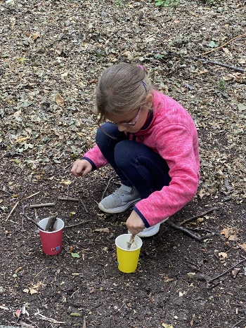 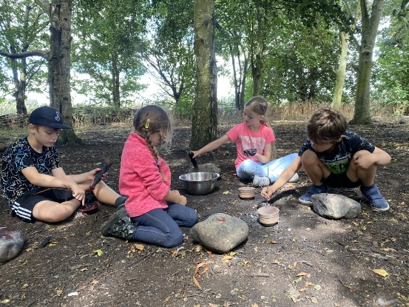 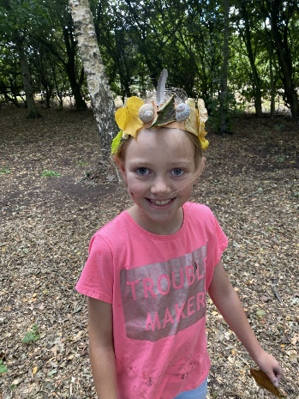

**Dragons & Mythical Creatures**

Become a dragon hunter and search for signs of dragons and mythical creatures, practice using a ‘Dragon’s Sneeze’ to help start our group camp fire and have a go at using natural materials to build a dragon’s lair. These creative and practical activities will encourage confidence building and provide opportunities for children to enjoy the natural environment.

Activities include;

*Design your own mythical beast*

*Build a dragons lair*

*Fire building*

*Scavenger hunt*

**Who lives here?**

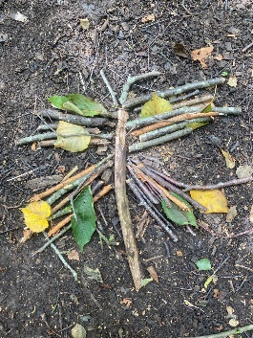Explore and discover what is around us in the natural environment, about food chains, habitats and how we can help and encourage wildlife.

Activities could include some or all of the following:

*Bug hotels*

*Bug hunts and identification*

*Creating habitats*

*Creating bird feeders*

*Mini shelter building*

**Woodland magic**

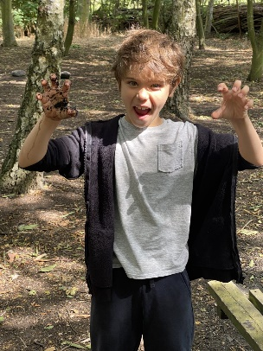Magic is everywhere, if you know where to look for it. This session brings the immersive magic of the forest to life with creative and hands on activities. Get busy setting the scene for a magical woodland feast for the fairy folk. Activities include;

*Mud Cakes*

*Natural bunting printing*

*Clay craft*

*Nature crowns*

*Scavenger hunts*

**Dinosaurs Adventures**

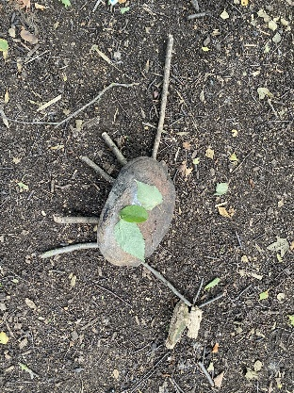160 million years ago, this area was under a shallow tropical sea, teeming with life.

Children will explore our prehistoric past through nature and participate in a variety of creative and problem-solving activities including:

*Building a nest for dinosaur eggs*

*Hunting for dinosaurs*

*Jurassic masks*

*Creating dinosaur footprints and more!*

**Other information:**

|  |  |
| --- | --- |
| **Duration:** | 10am- 11.30am or 1pm-2.30pm You are welcome to stay on site after the session has ended. Closing time is 4pm. |
| **Cost:** | £150 + VAT per group of up to 30 children. Minimum charge of £100 + VAT per group of up to 20 children. Children must be accompanied by supporting adults. |
| **Group size:** | We can accommodate up to 30 children per session. We can take bookings for 2 sessions per day. |
| **Ratio:** | Minimum ratio is 1 adult to 10 children. |
| **What to bring:** | * Please come in wellington boots or old trainers. Nothing you wouldn’t mind getting mucky. * Indoor shoes. If it is muddy, you will be asked to change into indoor shoes if you go into the Visitors Centre. * Waterproof clothing in case of wet weather and enough layers including hat and gloves when seasonally appropriate. We will be outdoors for the duration of the day. * Sunblock and a sun hat for warm sunny days, the forest school area is cool and shaded so ensure layers are packed even for warm days just in case. * The activities do involve getting messy so please do not send them in their best clothes. |
| **How to book:** | To book your visit please email [flagfenlearning@peterboroughlimited.co.uk](mailto:flagfenlearning@peterboroughlimited.co.uk) or phone 01733 317988. |